**Android activity life cycle: Design and develop an application to demonstrate the android activity life cycle. Also demonstrate the whole process through proper diagram.**

* **activity_main.xml**

<?xml version="1.0" encoding="utf-8"?>

<LinearLayout xmlns:android="http://schemas.android.com/apk/res/android"

android:layout_width="match_parent"

android:layout_height="match_parent"

android:orientation="vertical"

android:padding="16dp">

<EditText

android:id="@+id/emailEditText"

android:layout_width="match_parent"

android:layout_height="wrap_content"

android:hint="Email"

android:inputType="textEmailAddress" />

<EditText

android:id="@+id/passwordEditText"

android:layout_width="match_parent"

android:layout_height="wrap_content"

android:hint="Password"

android:inputType="textPassword" />

<Button

android:id="@+id/submitButton"

android:layout_width="wrap_content"

android:layout_height="wrap_content"

android:text="Submit"

android:layout_marginTop="16dp"/>

<Button

android:id="@+id/resetButton"

android:layout_width="wrap_content"

android:layout_height="wrap_content"

android:text="Reset"

android:layout_marginTop="8dp"/>

<TextView

android:id="@+id/displayTextView"

android:layout_width="match_parent"

android:layout_height="wrap_content"

android:text=""

android:layout_marginTop="16dp"

android:textSize="18sp"/>

</LinearLayout>

* **MainActivity.java**

package com.example.life_cycle;

import android.os.Bundle;

import android.util.Log;

import android.widget.EditText;

import android.widget.TextView;

import androidx.appcompat.app.AppCompatActivity;

public class MainActivity extends AppCompatActivity {

private EditText emailEditText;

private EditText passwordEditText;

private TextView displayTextView;

private static final String TAG = "life cycle";

// Called when the activity is first created.

@Override

protected void onCreate(Bundle savedInstanceState) {

super.onCreate(savedInstanceState);

setContentView(R.layout.activity_main);

Log.d(TAG, "onCreate called");

}

// Called when the activity becomes visible to the user.

@Override

protected void onStart() {

super.onStart();

Log.d(TAG, "onStart called");

}

// Called when the activity starts interacting with the user.

@Override

protected void onResume() {

super.onResume();

Log.d(TAG, "onResume called");

}

// Called when the system is about to put the activity into the background.

@Override

protected void onPause() {

super.onPause();

Log.d(TAG, "onPause called");

}

// Called when the activity is no longer visible to the user.

@Override

protected void onStop() {

super.onStop();

Log.d(TAG, "onStop called");

}

// Called before the activity is destroyed.

@Override

protected void onDestroy() {

super.onDestroy();

Log.d(TAG, "onDestroy called");

}

// Called after the activity has been stopped, just prior to it being started again.

@Override

protected void onRestart() {

super.onRestart();

Log.d(TAG, "onRestart called");

}

}

* 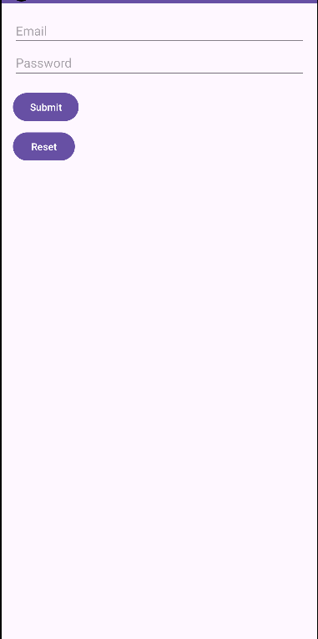**Output: -**
* **Logcat Output: -**

